**Images:**

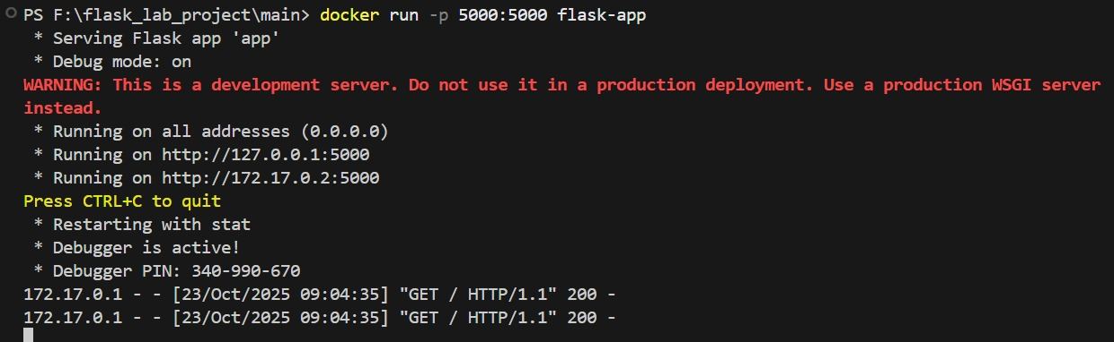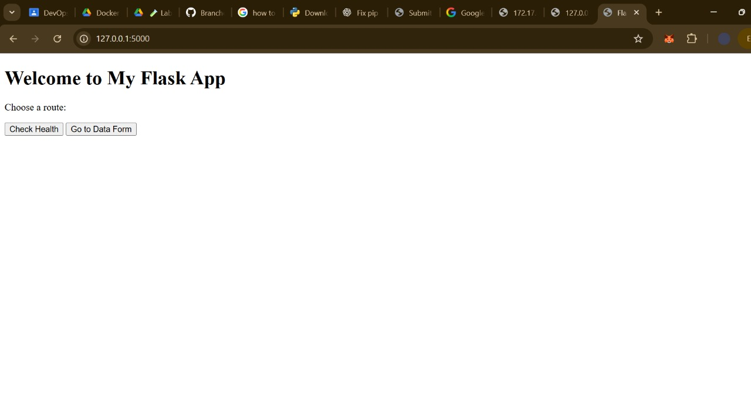

Link:

https://github.com/mabdullahalii/flask-lab-project.git